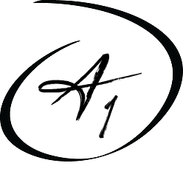
A1 Healthcare Staffing
5533 W. 109th Street, Oak Lawn, IL 60453
Phone: (708) 269-8665 Fax: (800) 730-1019
Email: a1healthstaff@gmail.com
Website: www.a1healthcarestaff.com

Employment Verification Request Form

Name: _______________________________________________ SSN: __________________
Employer: _______________________________________ Attn: ________________________
Fax: ______________________________________ Date: _____________________________

Authorization: I authorize my employer to verify the employment information requested below. I release such persons from liability for providing such information.

Signature: ______________________________________________Date: ________________

FOR EMPLOYER COMPLETION ONLY!!
Please Fax Information Back To: 800-730-1019

Exact Dates of Employment:
Start Date: ______________________________ End Date: ____________________________
Position: _______________________________________
Short Description of Job Duties:
____________________________________________________________________________
Check here if you can verify dates of employment and position held only

Reason for Leaving: Voluntary Involuntary Laid Off Terminated (circle one)

If Terminated, Reason for Termination:
____________________________________________________________________________
Eligible for Rehire: Yes No (Circle one) If No, why? ___________________________________

Verifier’s Name: (please print): ___________________________________________________
Signature: ___________________________________________________________________
Title: ___________________________________________ Date: _______________________

PRIVACY STATEMENT: This fax, including attachments, may include protected health information (PHI), confidential and/or proprietary information, and may be used only by the person or entity to which it is addressed or the individuals designated to view such information per HIPAA regulations. If the reader of this fax is not the intended recipient or his or her authorized agent, the reader is hereby notified that any dissemination, distribution or copying of this fax is prohibited. If you have received this fax in error, please destroy it immediately.

