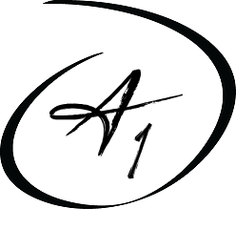
A1 Healthcare Staffing
5533 W. 109th Street, Oak Lawn, IL 60453
Phone: (708) 269-8665 Fax: (800) 730-1019
Email: a1healthstaff@gmail.com
Website: www.a1healthcarestaff.com

Hepatitis B Vaccination Form

O.S.H.A. regulation states that all healthcare professionals with occupational exposure to blood
borne pathogens must be offered the hepatitis B vaccinations. You have been determined to be
at risk to blood borne pathogens.

A. I have already received the hepatitis B vaccine.

B. I decline the hepatitis B vaccine

C. If interested with the hepatitis B vaccine, I may contact my local County Health Department.

I understand that due to my occupational exposure to blood or other potentially infectious
materials I may be at risk of acquiring hepatitis B virus (HBV) infection. I have been given the
opportunity to be vaccinated with hepatitis B vaccine. However, I decline hepatitis B vaccination
at this time. I understand that by declining this vaccine, I continue to be at risk of acquiring
hepatis B, a serious disease. If in the future I continue to have occupation exposure to blood or
other potentially infectious materials and I want to be vaccinated with hepatitis B vaccine, I can
receive the vaccination series.

Print Name ______________________________________________________________

Sign Name ___________________________________________ Date:_______________

